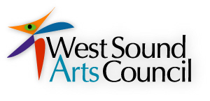
MEMBERSHIP 2012

The West Sound Arts Council is a nonprofit, 501(c)(3), organization promoting the arts in Kitsap County and beyond.

Yes! I want to join West Sound Arts Council.

_____$25 Individual member

_____$40 Family member

_____$75 Business member

_____$100 Patrons

______I would be interested in serving on the Board or Sub-Committee!

Name __________________________________________________________________

Address ________________________________________________________________

Phone ___________________E-mail___________________________________

Interest/Hobbies; ie.. I am an artist-play in a band-etc…. ________________________________________________________________________

________________________________________________________________________

Mail to:

WEST SOUND ARTS COUNCIL, P.O. Box 2464, Bremerton, WA 98310
Your donation is tax deducible.

THANKS FOR YOU SUPPORT OF THE ARTS!

